REAL LIFE AND DISTANCE – TIME GRAPHS
Pearson Edexcel - Thursday 7 June 2018 - Paper 2 (Calculator) Higher Tier
1.
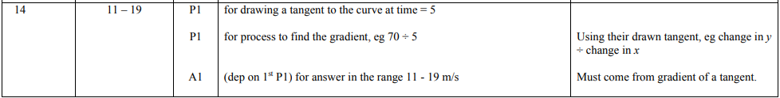
Pearson Edexcel - Monday 6 November 2017 - Paper 2 (Calculator) Higher Tier
2.
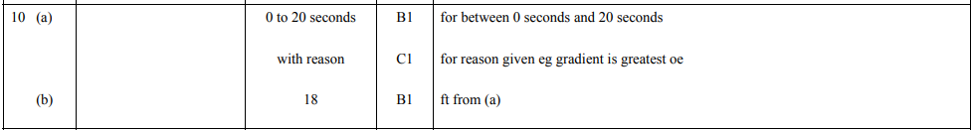
Pearson Edexcel - Sample Paper 1 - (Non-Calculator) Higher Tier
3.
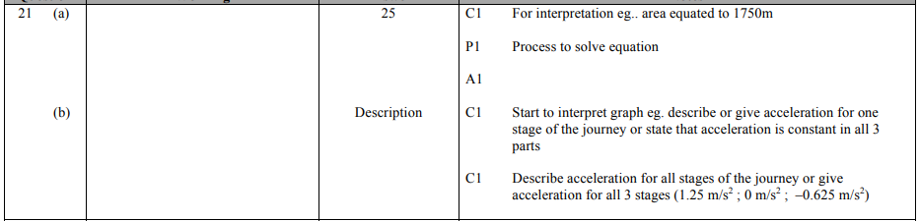
Pearson Edexcel - Monday 4 March 2013 - Paper 2 (Calculator) Higher Tier
4.
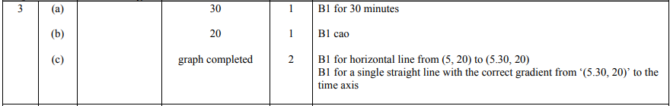
Pearson Edexcel - Monday 7 June 2010 - Paper 3 (Non-Calculator) Higher Tier
5.
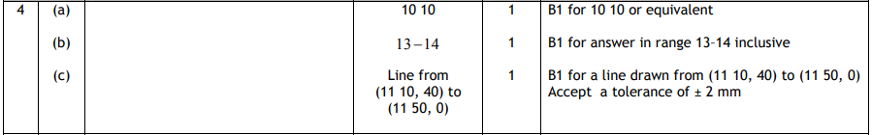
OCR GSCE – Tuesday 3 November 2020 – Paper 4 (Calculator) Higher Tier
6.
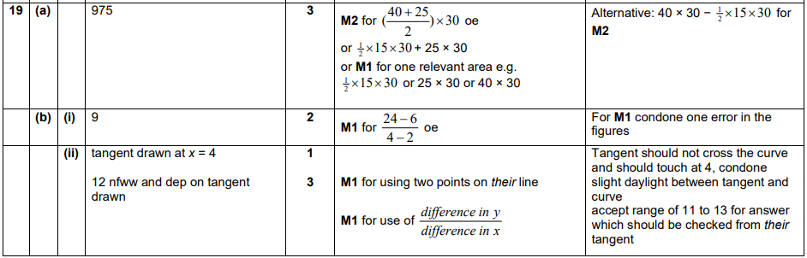
OCR GSCE – Monday 9 November 2020 – Paper 6 (Calculator) Higher Tier
7.
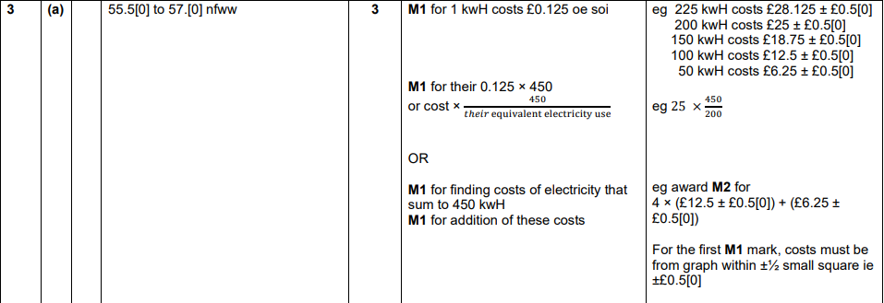
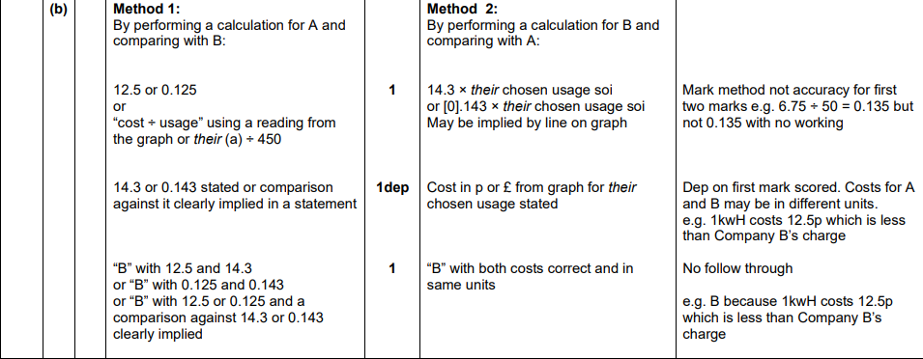
OCR GSCE – Tuesday 5 November 2019 – Paper 6 (Calculator) Higher Tier
8.
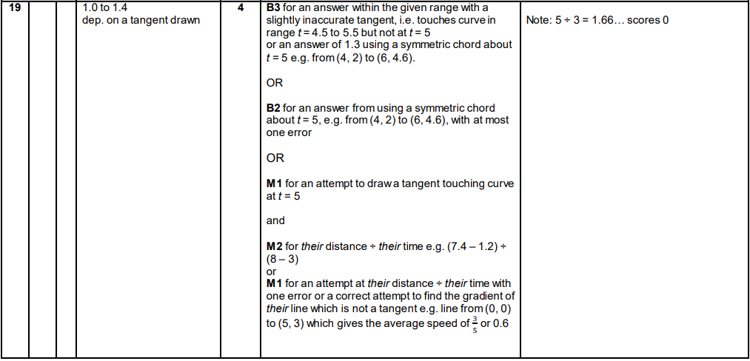
OCR GSCE – Tuesday 21 May 2019 – Paper 4 (Calculator) Higher Tier
9.
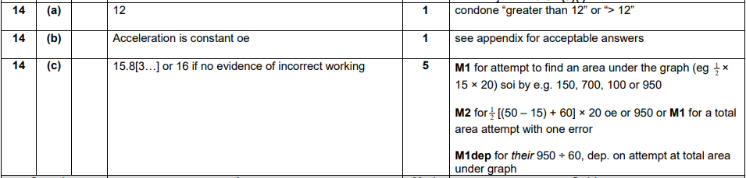
OCR GSCE – Monday 12 November 2018 – Paper 6 (Calculator) Higher Tier
10.
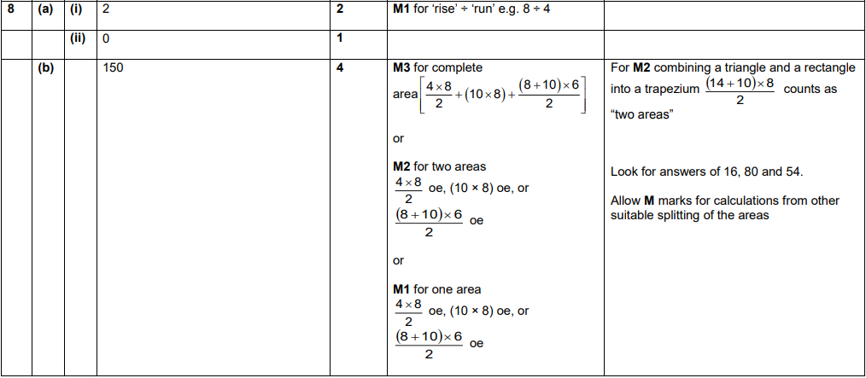
OCR GSCE – Tuesday 12 June 2018 – Paper 6 (Calculator) Higher Tier
11.
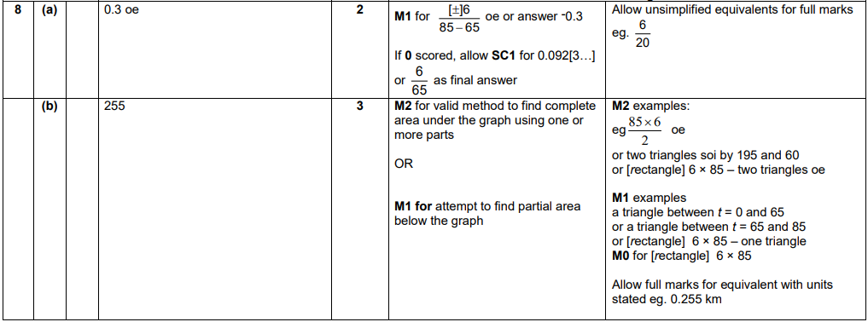
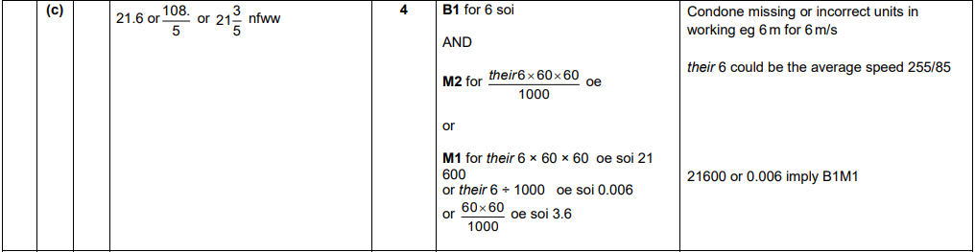

OCR GSCE – Tuesday 6 November 2017 – Paper 5 (Non - Calculator) Higher Tier
12.
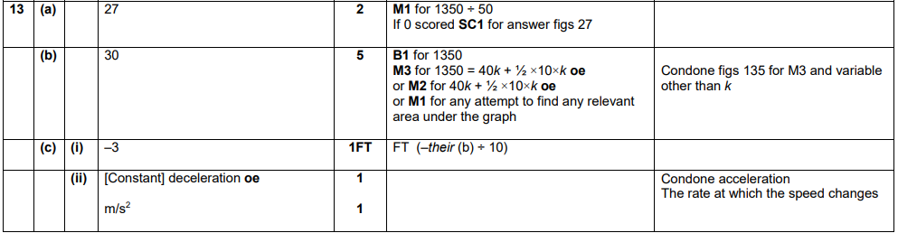
OCR GSCE – Thursday 25 May 2017 – Paper 4 (Calculator) Higher Tier
13.
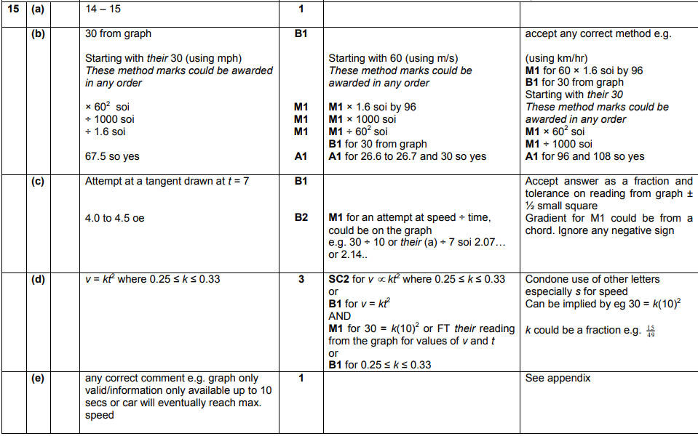
OCR GSCE – Thursday 25 May 2017 – Paper 4 (Calculator) Higher Tier
14.
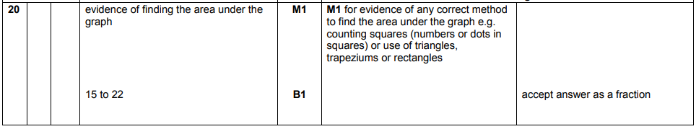
OCR GSCE – Thursday 8 June 2017 – Paper 5 (Non - Calculator) Higher Tier
15.
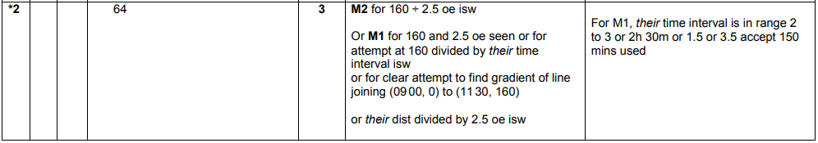
OCR GSCE – Sample Papers – Paper 5 (Non - Calculator) Higher Tier
16.
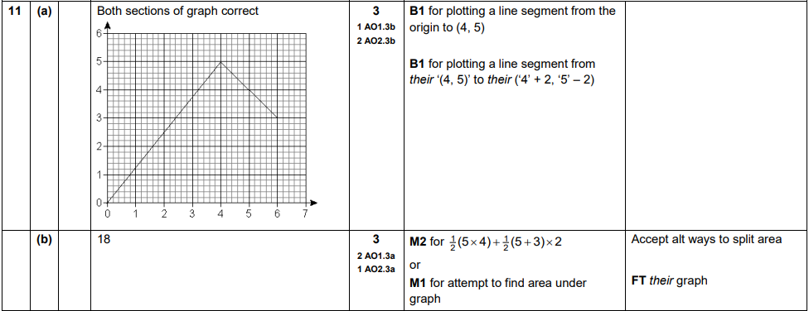

OCR GSCE – Sample Papers – Paper 6 (Calculator) Higher Tier
17.
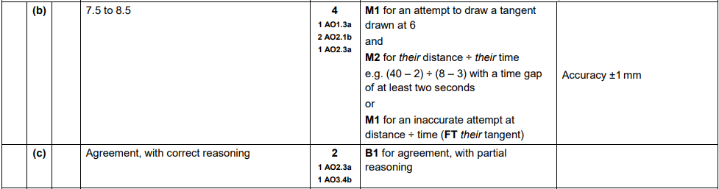
AQA GSCE – Thursday 4 June 2020 – Paper 2 (Calculator) Higher Tier
18.
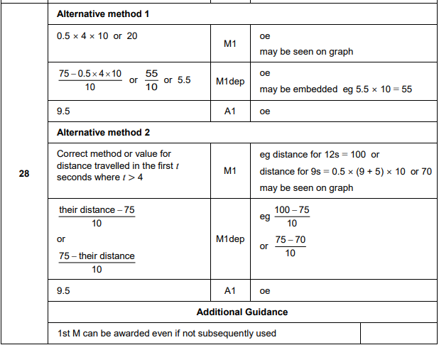
AQA GSCE – Thursday 8 June 2020 – Paper 3 (Calculator) Higher Tier
19.
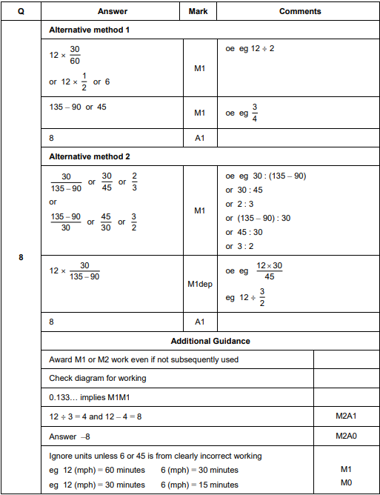

AQA GSCE – Tuesday 11 June 2019 – Paper 3 (Calculator) Higher Tier
20.
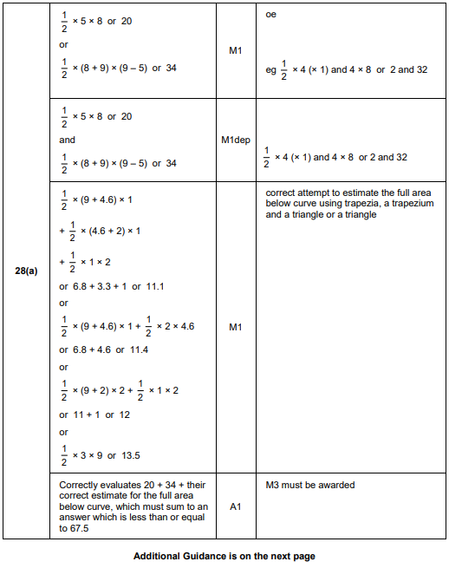
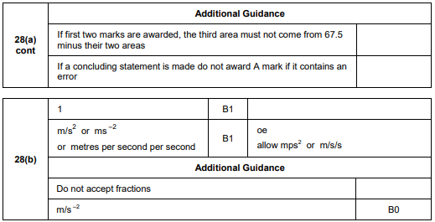
AQA GSCE – Tuesday 6 November 2018 – Paper 1 (Non - Calculator) Higher Tier
21.
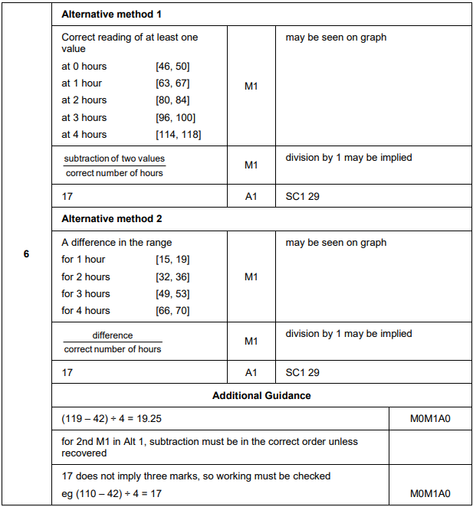
AQA GSCE – Thursday 8 November 2018 – Paper 2 (Calculator) Higher Tier
22.
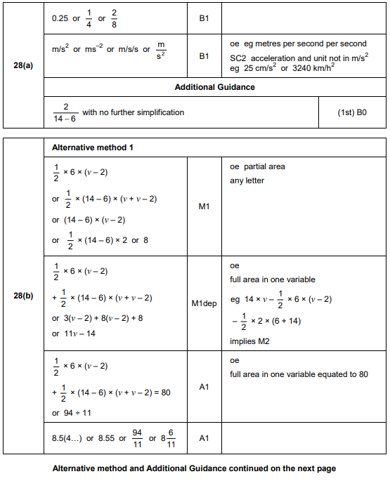
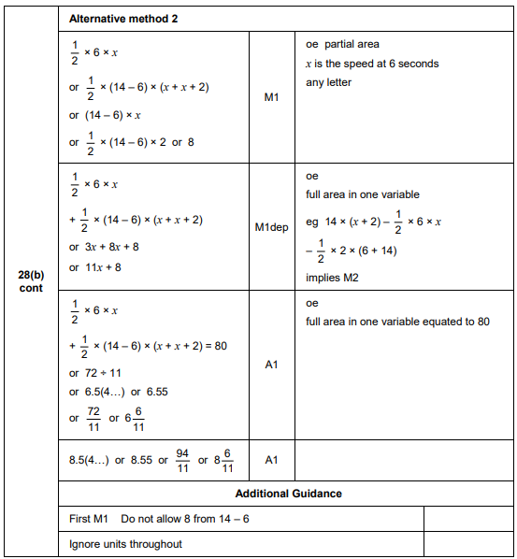
AQA GSCE – Thursday 7 June 2018 – Paper 2 (Calculator) Higher Tier
23.
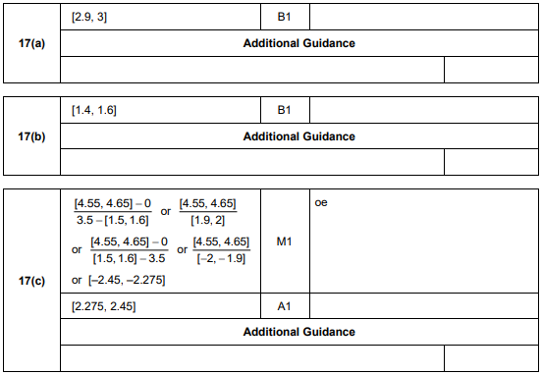
AQA GSCE – Tuesday 12 June 2018 – Paper 3 (Calculator) Higher Tier
24.
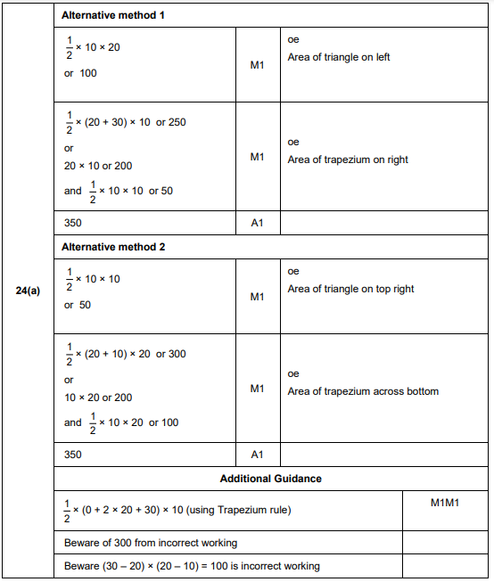
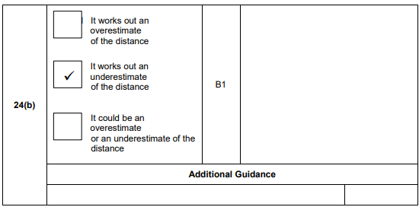
AQA GSCE – Thursday 2 November 2017 – Paper 1 (Non - Calculator) Higher Tier
25.
AQA GSCE – Thursday 6 November 2017 – Paper 2 (Calculator) Higher Tier
26.
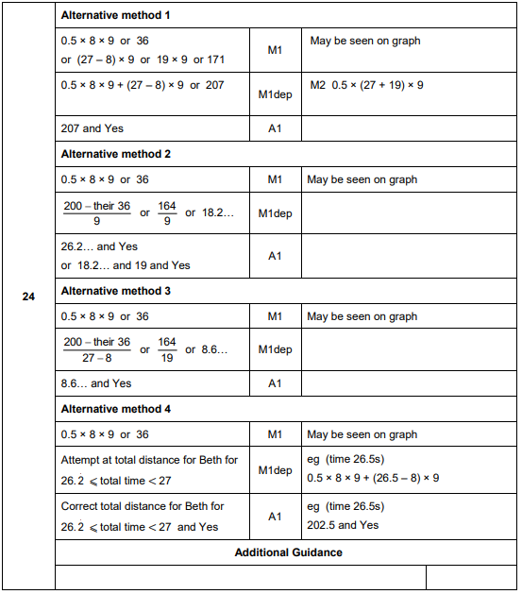
AQA GSCE – Wednesday 8 November 2017 – Paper 3 (Calculator) Higher Tier
27.
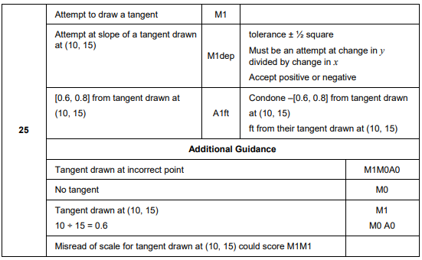
AQA GSCE – Wednesday 25 May 2017 – Paper 1 (Non - Calculator) Higher Tier
28.
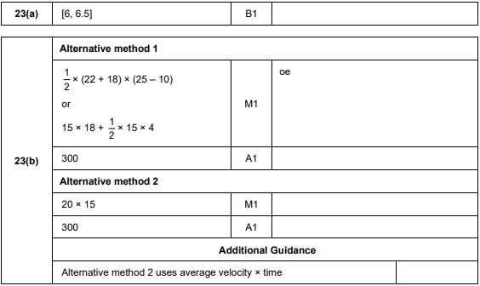

AQA GSCE – Thursday 8 June 2017 – Paper 2 (Calculator) Higher Tier
29.
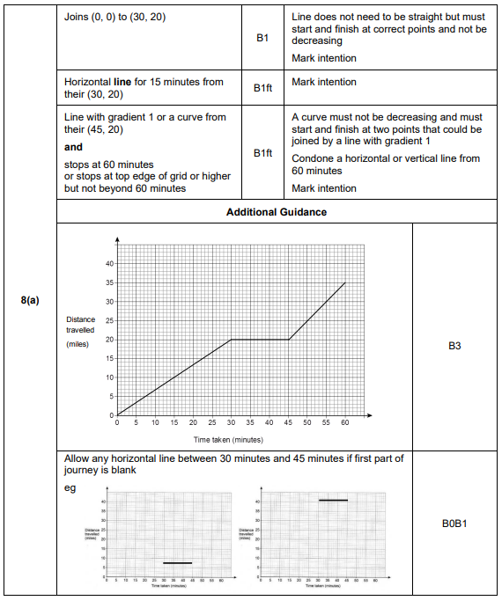
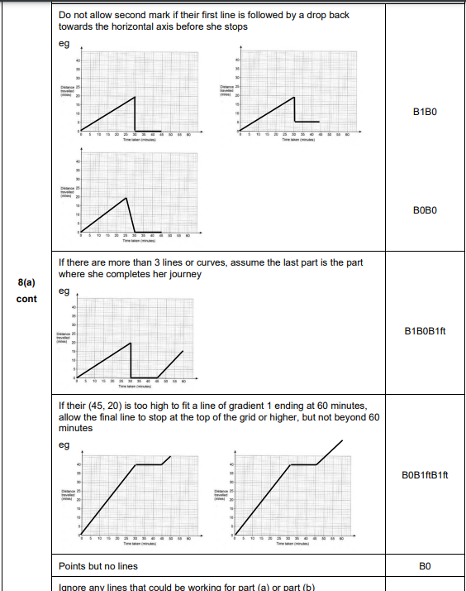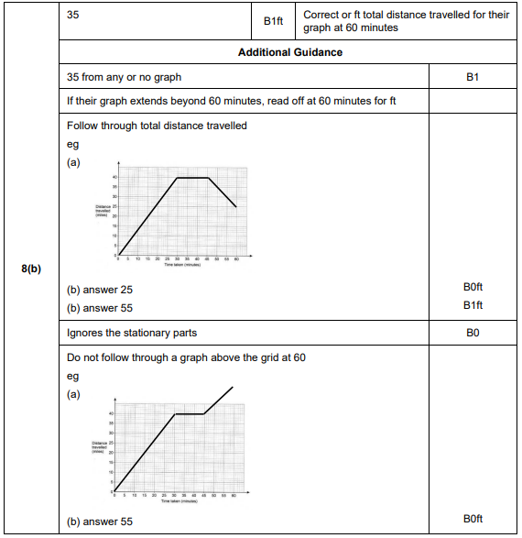

AQA GSCE – Tuesday 13 June 2017 – Paper 3 (Calculator) Higher Tier
30.
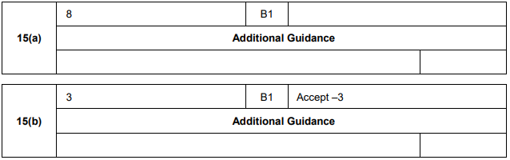
AQA GSCE – Tuesday 13 June 2017 – Paper 3 (Calculator) Higher Tier
31.
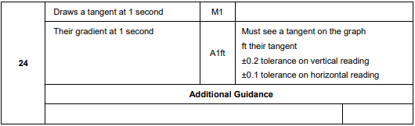
AQA GSCE – Sample Paper 1 (Non - Calculator) Higher Tier
32.
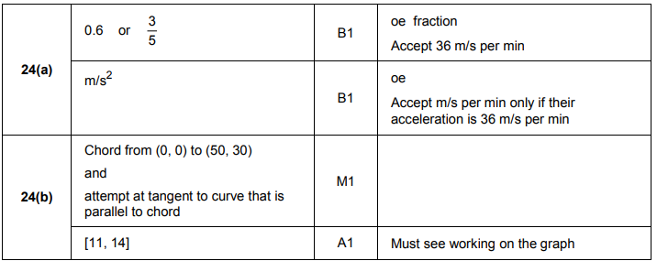

AQA GSCE – Sample Paper 3 (Calculator) Higher Tier
33.
